**Academic Direction: University College London (UCL)**

**DON'S GLOBAL UNIVERSITY**

[Home](https://www.ucl.ac.uk/)

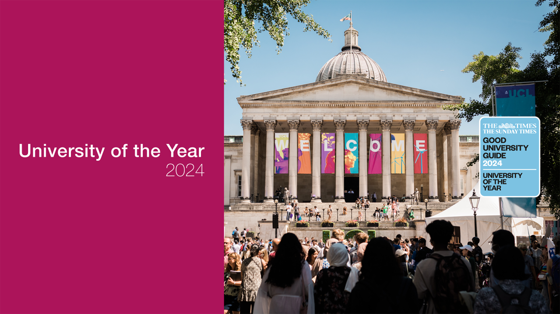

**Gain knowledge. Gain advantage.**

[[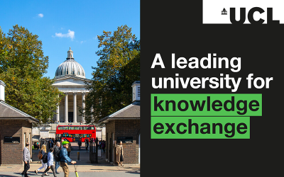](https://www.ucl.ac.uk/news/2024/sep/ucl-retains-its-position-leading-institution-fourth-knowledge-exchange-framework)](https://www.ucl.ac.uk/news/2024/sep/ucl-retains-its-position-leading-institution-fourth-knowledge-exchange-framework)

**[UCL retains its position as a leading institution in fourth Knowledge Exchange Framework](https://www.ucl.ac.uk/news/2024/sep/ucl-retains-its-position-leading-institution-fourth-knowledge-exchange-framework)**

**1st**

UCL is University of the Year 2024 (The Times and Sunday Times Good University Guide 2024)

**2nd**

UCL was rated 2nd in the UK for research power in the Research Excellence Framework 2021

**9th**

UCL is ranked 9th in the 2025 QS World University Rankings

**30**

There have been 30 Nobel Prize laureates amongst UCL’s alumni and current and former staff to date